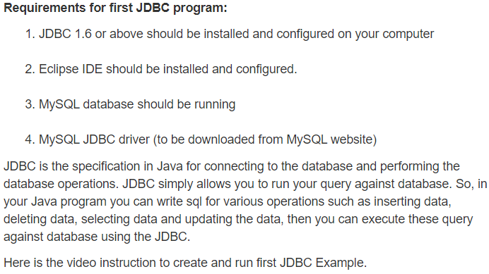

<https://youtu.be/jiGFhqD5elk>

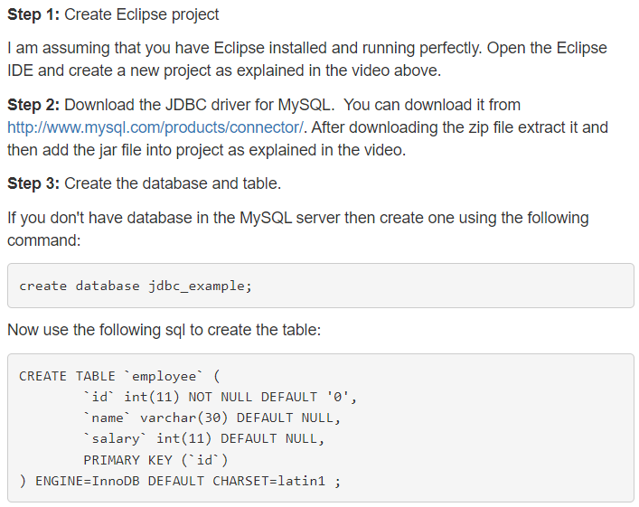

­

import java.sql.*;

public class InsertValues {

public static void main(String[] args) {

System.out.println("Inserting values in Mysql database table!");

Connection con = null;

String url = "jdbc:mysql://localhost:3306/";

String db = "jdbc_example";

String driver = "com.mysql.jdbc.Driver";

try {

Class.forName(driver);

con = DriverManager.getConnection(url + db, "root", "root");

try {

Statement st = con.createStatement();

String sql = "INSERT employee (id,name,salary) VALUES(" + 1 + ","

+ "'Deepak Kumar'," + "1000)";

System.out.println(sql);

int val = st.executeUpdate(sql);

System.out.println("1 row affected");

} catch (SQLException s) {

System.out.println("SQL statement is not executed! Error is: " + s.getMessage());

}

} catch (Exception e) {

e.printStackTrace();

}

}

}

